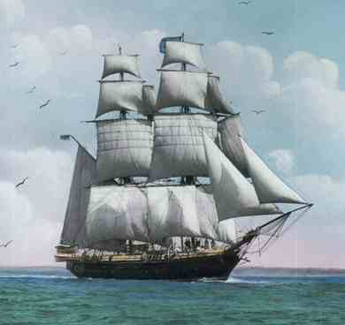
Name ________________________________________

The True Confessions of Charlotte Doyle
Study Questions – Chapters 7-12

Chapter 7
- Why didn’t Charlotte tell the captain about her adventure in the hold?

- Why did Charlotte keep the dirk?

- In Chapter 7 Miss Doyle has the strange feeling that both Zachariah and Jaggery are trying to win her love.

A) What are they really trying to do?
B) What advantage would each have in doing so?

Chapter 8
- Why were the crew’s quarters off-limits to Charlotte?

- What did Charlotte’s response to Zachariah’s gift of sailor’s clothing indicate about the development of her character?

- What did Charlotte’s boredom lead her to take part in on the ship?

- What did you learn about life on a ship in this chapter (if you didn’t already know)? What was it like to be a sailor during this time period?

- What do you think Charlotte meant at the end of chapter eight when she said, “But the storm was – at first – man-made”? To what different kinds of storms might she have been referring?

Chapter 9
- What did volunteering to go to Ewing’s needle indicate about the change in Charlotte’s character?

- What does the conversation that Charlotte overheard seem to be about? BE SPECIFIC

- What two alarming things did Charlotte see in Ewing’s trunk?

- What realization does Charlotte come to after thinking back on how many men she saw in the forecastle (crew’s quarters)? How does this connect to the face she saw in steerage?

- Although Charlotte had been spying on the crew, how did she feel in Chapter Nine when they began to spy on her?

- How does Captain Jaggery react to Charlotte when she tells him about what she saw in the forecastle?

Chapter 10
- What did all of the crew have (except Zachariah)? What does Jaggery have as defense against the crew?

- What was the identity of the stowaway?

- a) What demand does the stowaway make? b)What does Captain Jaggery do in response?

- Charlotte expresses many emotions in this chapter. What are some of Charlotte’s feelings towards the actions that take place? Explain.

- Zachariah is the only person who steps forward to tend to the dead body. What does Jaggery do in response to his kindness toward the dead man and questioning his orders to throw the corpse overboard?

Chapter 11
- What does Zachariah say about Charlotte when he is speaking to Jaggery? What does this reveal about his character?

- Mr. Hollybrass hesitates often when taking orders from Jaggery. What does this reveal about his feelings?

- Do you think the captain knew he would upset Charlotte by hurting Zachariah? What explanation can you provide for him wanting to hurt/upset Charlotte?

- Why does Hollybrass continue to carry out Jaggery’s orders?

- How does the crew finally help Zachariah?

Chapter 12
- What is Jaggery’s reaction when Charlotte goes to his cabin to beg his forgiveness? BE SPECIFIC!

- After Charlotte leaves the captain’s cabin, what does she witness on the quarterdeck?

- How does the captain punish the crew?

- What announcement does Charlotte make at the end of this chapter?

