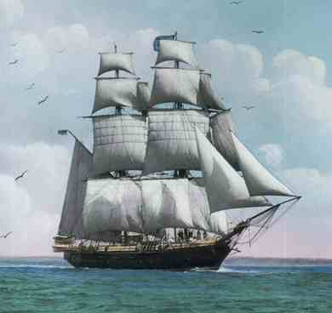
Name ________________________________________

The True Confessions of Charlotte Doyle
Study Questions – Chapters 13-17

Chapter 13
- Foley calls Charlotte “A pretty girl” but she says it was not meant as a compliment. What did he mean by it?

- What are some of the warnings the crew gives Charlotte about joining or “signing” with them?

- How does Foley describe Charlotte’s hands? What does it mean in your own words?

- What does Charlotte mean when she said, “And yet I had to climb. This was my restitution.”? Look up restitution in the dictionary if you are unsure of what the word means.

- In chapter 13, the author tries to get you to appreciate the height and the danger involved in Charlotte’s task. To do this he must compare the climb to something you are more familiar with. Therefore, he uses a lot of similes, which are comparisons that use the words “like” or “as” Find and write TWO similes from chapter 13 (see page 146). Explain what each one means.

Chapter 14
6. Why was Charlotte's clothing such an important issue for the captain?

7. How did the crew handle the situation with Charlotte (a female) staying in the forecastle with them?

8. Captain Jaggery and the crew decided to call Charlotte by different names. What was the significance of the new names?

9. How does the captain plan to get them across the Atlantic Ocean faster? Why is this a problem?

Chapter 15
- What do Hollybrass and Jaggery argue about?

- Charlotte had to climb the mast to cut the line to save the sail. In the process, she nearly falls to her death. Who saves her? Why is this so surprising?

- When the Seahawk reaches the eye of the hurricane, Hollybrass is discovered face down with Charlotte’s dirk in his back. Predict who you think killed Hollybrass. What evidence leads you to believe or not believe that it was Charlotte?

Chapter 16
- At Hollybrass’s funeral, whom does the captain blame for the first mate’s death? What motive would this person have to commit murder, according to the captain?

- What does it mean when the crew calls Charlotte “Miss” again?

- Why do you believe the crew turned against Charlotte and believed Captain Jaggery’s words?

- Who does Charlotte encounter in the brig?

Chapter 17

- Who has been helping Zachariah to hide? Why wasn’t Charlotte told about this?

- Was Charlotte correct about the difficulty Zachariah would have had in taking Captain Jaggery to court in Rhode Island in 1832? Explain your response.

- Why does Charlotte now think the crew did not stand up to defend her?

- What is the penalty for killing a shipmate?

