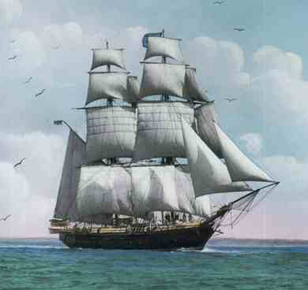
Name ________________________________________

The True Confessions of Charlotte Doyle
Study Guide – Chapters 1-6

An Important Warning (preface)
- Decide why the author chose to begin the novel with this preface.

- What are three things you learn about the protagonist in this preface?

Chapter 1
- Describe Mr. Grummage’s character. Come up with at least two character traits to describe him and use a detail from the chapter to support each trait.

- Why was Charlotte distressed to discover that she would be the only passenger aboard the ship?

Chapter 2
- A) With whom does Mr. Grummage argue?
B) What do they seem to be arguing about?

- What was your first impression of Mr. Keetch? Explain how the author creates this impression (examples of language/descriptions).

- Describe Charlotte’s cabin.

- What warning does Mr. Barlow give to Charlotte?

- What does Zachariah give to Charlotte?

- What does the conversation that Charlotte overhears seem to be about? BE SPECIFIC!

Chapter 3
- When Charlotte woke up, from what ailment did she find herself suffering?

- What did Captain Jaggery mean when he said, “we shall have no democracy here”?

- There are several images in this chapter that are quite frightening.

A) Which one do you feel was most frightening?

B) How does the author use vivid language to create these images?

C) Predict what these images may have to do with future events.

Chapter 4

14. Who is Mr. Cranick? Explain how he plays a role in the story.

15. Zachariah thinks the men signed on again for a particular reason. What is that reason?

Chapter 5
16. Describe Captain Jaggery’s cabin.

17. Who does the captain remind Charlotte of?

18. Explain the meaning of the round robin.

19. Captain Jaggery tells Charlotte that “you can be my eyes and ears among the men.”
Should Charlotte listen to him? Why or why not?

20. A) Why do you think Charlotte lies about where she got the dirk?
B) If she told the truth, draw some conclusions about what may have happened to Zachariah based on the information you know about Captain Jaggery’s methods for running a ship.

Chapter 6
21. Why did Captain Jaggery have the crew set all the sails?

22. Summarize the advice Mr. Barlow tries to give Charlotte in this chapter and state one difference between this advice and the advice he tried to give her before.

23. What eerie feeling did Charlotte have in the darkened hold? What might this scene be foreshadowing?

24. A) What is a brig?
B) In your opinion, why won’t the captain travel without one?
C) What does this tell us about his character? Use details from the text to support your answer.

